Victorian Council for Civil Liberties Inc
Reg No: A0026497L
GPO Box 3161
Melbourne, VIC 3001
t 03 9670 6422
info@libertyvictoria.org.au
PRESIDENT
Julia Kretzenbacher
SENIOR VICE-PRESIDENT
Sam Norton
VICE-PRESIDENTS
Jamie Gardiner OAM
Thomas Kane
Monique Mann
IMMEDIATE PAST PRESIDENT
Julian Burnside AO QC
TREASURER
Michelle Bennett
SECRETARY
Martin Radzaj
PATRON
The Hon. Michael Kirby AC CMG
Office of the Australian Information Commissioner (OAIC) - National Health (Privacy)
Rules 2018 review

Liberty Victoria thanks the OAIC for the chance to provide comment on this Privacy Review. Liberty attended a tele conference on 31st May 2021 and have read the Consultation Paper as part of our preparation.

The range of rules, regulations and laws that govern the Pharmaceutical Benefits Scheme (PBS) and the Medical Benefits Schedule (MBS) are a mish mash which has had differing layers added over time. The overriding Australian Privacy Principles (APP) now have to be viewed in addition to the rules inherent in the PBS and MBS.

The definitions used in the National Health (Privacy) Rules are not outdated. They are sufficiently technologically neutral to be applicable now and in the future.

It should be noted that Principles of Privacy and Governance should be the starting point – technological needs should always be subordinate to desired outcomes. Designing the Rules based on technological possibilities is a poor way to begin.

Perhaps the simplest reworking of the current rules would be to remove all the items with wordage and principles contained within the APP – to stop any vagaries of dual but slightly differing language. This would leave the Health Services with a set of principles specific to the PBS/MBS data sets and needs.

Given the demands on the data-sets from both Government research and ethically acceptable commercial projects it is perhaps a more important goal to define public interest tests in a fashion which is not so slanted to overrule data privacy.

As was noted repeatedly in the online consultation – the personal ownership of health data and the effect of poor anonymization are not given sufficient weight in the processes as currently practised. The data- sets are largely treated as public assets rather than the outcomes of individual treatment. Further uses for public good are therefore viewed in a positive light due to this socialisation of client records by annexation.

Liberty Victoria believes that this review should provide a statement that client records are first and foremost the property of the clients, and any further uses must be viewed in narrow tightly considered circumstances. This is the platform for any Third Party uses or any limited mixing of data from MBS and PBS. Human dignity and personal security are central to the protection of this data.

The one area where some change to reduce the restrictions may be appropriate was in the time given for combined data sets to be held – 30 days was mentioned. This might be subject to extension depending on the size and scope of the research project.

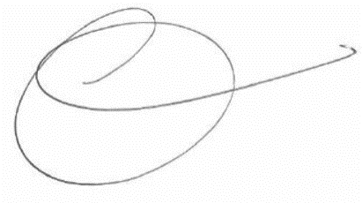

Dr Monique Mann
Vice-President, Liberty Victoria

