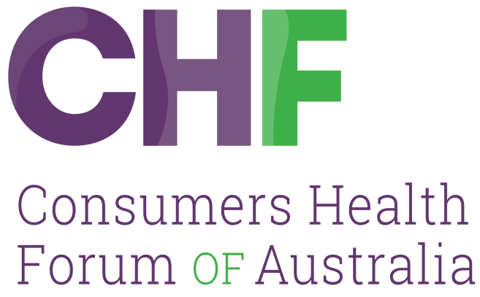

RESPONSE

NATIONAL HEALTH (PRIVACY) RULES 2018 REVIEW
OFFICE OF THE AUSTRALIAN INFORMATION COMMISSIONER

June 2021

Consumers Health Forum of Australia (2021) Response to National Health (Privacy) Rules 2018 Review, Office of the Australian Information Commissioner.

P: 02 6273 5444
E: info@chf.org.au
twitter.com/CHFofAustralia
facebook.com/CHFofAustralia
Office Address
7B/17 Napier Close,
Deakin ACT 2600
Postal Address
PO Box 73
Deakin West ACT 2600

Consumers Health Forum of Australia is funded by the Australian Government as the peak healthcare consumer organisation under the Health Peak and Advisory Bodies Program

Consumers Shaping Health

Introduction
CHF agree with the importance of sharing and using health data in a safe and consistent way for the public good in the context of improving health services, developing health policies and priorities, and improving health outcomes.
In terms of data privacy research indicates that consumers rate their health data as one of their highest concerns when it comes to privacy. The OAIC 2020 survey on consumer attitudes to data privacy demonstrated that:
- 40% of Australians are comfortable with government using data collected for research, service, or policy development;
- 84% consider supplying information to an organisation for a specific purpose and the organization using it for another purpose to be misuse, and;
- 83% of Australians want government to provide more protection of the privacy of their data.
This and other research illustrate a consistent tension between the consumers’ privacy concerns and a general willingness to share data for the public good in terms of health service delivery, policy development, identification of health priorities.
It also reflects the importance into the future of establishing clear and stated ranges of purposes and perhaps even anticipated purposes of data collection. The problem with National Health Act 1953 is the original collection of PBS and MBS data were for narrow purposes and as technology developed the Section 135AA amendment was aimed at addressing justified concerns about function creep in the purpose of collection and use of MBS and PBS data.

Rules – Fit for Purpose
CHF believes that the combination of The Australian Privacy Principles and the National Health (Privacy) Rules 2018 have been enablers for an improved understanding of limits and concessions in relation to data linking, sharing and privacy protection measures. It is our view that the Rules work well.
In terms of whether some provisions in the rules remain fit for purpose CHF agrees that some of the language does not reflect technology advances since the amendment of the National Health Act 1953, Section 135AA. CHF supports changes to the Rules which better reflect current technology, particularly that related to data storage systems.
The Covid-19 pandemic has also highlighted the need for potential changes in the Rules related to data use in a national health emergency. Change in behaviors during Covid had privacy implications as governments sought and introduced technology solutions to prevent and manage Covid, including treatment, management of patients and disease prevention. While other areas of Australian law related to health may address key issues it would be of value to ensure that the Rules are considered in light of Australia’s experience during Covid-19. During the Covid 19 pandemic Australians demonstrated that they were willing to make concessions in relation to privacy and confidentiality for the public and national good. A second OIAC survey on consumer attitudes to data privacy undertaken from 7 -9 April 2020 to aimed to assess the impact of Covid on attitudes to privacy in comparison with results from the first survey undertaken earlier in 2020. 60% of Australians agreed that during Covid some concession must be made in relation to privacy protection if they are not permanent.

Balance of Privacy and Use – Consumer Trust
CHF considers that overall, the balance between protection of privacy on the one hand and use of claims information on the other is generally appropriate. However, it is our view that consumer understanding of the protections provided by the Rules is limited. Consumer support for sharing of their data is based on a level of trust and particularly in relation to the uses to which their data will be put. Maintaining or increasing trust requires consumers to understand quite clearly how their information will be used and any exceptions to key purposes.
Individuals are likely to be more willing to allow data about themselves to be used provided they understand why and how the data is being used, can see tangible benefits, and have control over who the data is shared with.
Outcomes from the 2017 Productivity Commission report Data Availability and Use identified consumer trust as a key issue, and that community trust and acceptance can be built through enhancement of consumer rights, genuine safeguards, transparency, and effective management of risk (Finding 4,2). Further the review noted that, without appropriate regard being given to consumer rights over data, the “social licence” to make greater use of growing future data availability will be challenging. Effectively government needs to work with consumers to build trust and in turn secure consent.
In the interests of transparency aimed at maintaining and increasing trust and acceptance it is important to provide consumers with information that outlines how our laws and institutions are protecting their data privacy as well as how, why, and when their data is used. In this context the Rules simply set down how agencies may use, store, disclose and link PBS and MBS claims information. CHF considers that, as a trust building strategy, a basic “consumer explainer” is needed to accompany the Rules. This should outline in plain English how the Rules protect the privacy of their PBS and MBS data. It should also outline the key uses of their de-identified data in terms of sharing and linking, including compliance processes, entitlements, service delivery and policy development. Importantly the limits on use of use of identified data should be explained.

Technical Standards – Services Australia
CHF believes that the dedicated technical standards for MBS and PBS claims data bases should remain, particularly because they enable more specific requirements in managing data linkage and safeguarding data from unauthorized linking. This is important given the range of other functions undertaken by Services Australia which potentially create risks should data linkage not be adequately safeguarded.

Medical research
While CHF remains relatively comfortable with the Rules in relation to Disclosure of Identifiable claims information for medical research it is our view that an additional caveat should be added to the Rules in relation to the destruction of the claims information at the conclusion of the research project. CHF supports Rule 12 (2) which requires a written undertaking by the researcher to destroy identified claims data. However, we believe this is inadequate. CHF suggests an additional requirement that the researcher confirm and advise when the identified data is destroyed. There are particular concerns around this Rule where for private for-profit research is involved.

Use of Claims Information
In terms of enabling a wider range of circumstances in which the Department of Health be able to link de-identified claims information CHF would generally disagree with such a proposal. However, the experience of Australian’s during Covid 19 illustrate specific circumstances where such linkages may be important in terms of the national good and may be acceptable to consumers. We would thus suggest that this question be considered in terms of perhaps temporary concessions in the Rules, where it is relevant and essential to the management of a national health emergency. As the OAIC survey indicated Australians indicated they were willing to accept concessions in this situation as long as they were not permanent.

Prescriptive Versus Principle Based Rules
CHF supports maintaining a prescriptive approach to the Rules. This represents a level of transparency in the rules governing use of data which is vital for consumer support and acceptance. A principle-based approach risks consumer perceptions that opportunities may exist for function creep. As outlined earlier consumers’ trust is based on a clear understanding of the purpose for collecting their data and its use. As the OAIC survey indicated 84% of Australians surveyed considered supplying information to an organisation for a specific purpose and the organisation using it for another purpose to be misuse. This indicates that consumers are likely to have a very high level of concern around risks of function creep. A principles-based approach may be seen as less transparent in terms of purpose and a perception that the Rules may be somewhat elastic.
While we accept that a more prescriptive approach may inadvertently block reasonable activities or be complex to apply in practice it is CHF’s view that an ongoing cycle of review of the Rules can address these issues. It is likely that technology advances will ultimately require further review of the Rules. Indeed, the likelihood of potential new pandemic threats and responses, or other global health threats, may require such reviews. At present it is a situation of working with what we know now and what can be reasonably anticipated into the future.

Miscellaneous – Rule 15 (1) – (4) – Paper Copies
CHF believes that some amendment to this section is required. The Rule states that paper copies of claims may be made where reasonably necessary for a lawful purpose. It would enhance the strength of this Rule if it were referenced to Rule 9, Linkage of Claims Information which sets out “lawful purposes”. We would also query why there is no reference to destruction of paper copies once the purpose is completed but again this may simply require a reference to Rule 10 (1) that linked claims information must be destroyed as soon as practicable after meeting the purpose for which it was linked. This proposed amendment to Rule 15 would provide better guidance to Services Australia and Department of Health Staff (15 (3)) on the relevant Rules, particularly as overall the Rules, and indeed the Section 135AA of the National Health Act 1953, focus on technological linkages.

